SureClinical Desktop Client
Navigation and Quick Tips Guide

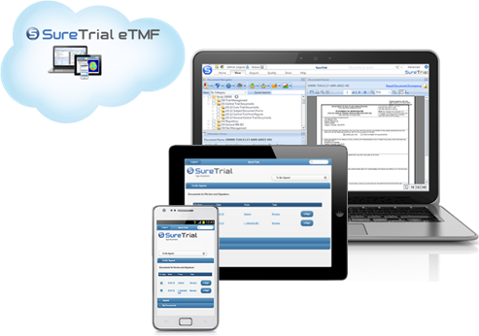

August, 2014

Table of Contents
1 Navigation and Quick Tips Guide 3
1.1 Tree View 3
1.2 View “By” Settings 3
1.3 Document Filter 4
1.4 Gadget: Setting Your Personal Viewing Preferences 4
1.5 Quick Find: A Way to Find Specific Folders Quickly 5
1.6 Basic Search 5
1.7 Advance Search 6
1.8 “Right-Clickling” in the Document Tree 7
1.9 Document Naming Conventions 8
1.10 Visual Indicators via Document Icons 9
1.11 Document Status Annotations 9
1.12 Viewing the Content Model Editor 10
1.13 Reserve Folders – “Hiding Unused Folders” 10
1.14 Uploading Documents 11
1.15 Drag and Drop: The Easy Way to Acquire Documents 13
1.16 Creating a Binder 14
1.17 Bookmarks: Securely Share Documents with Colleagues 15
1.18 Checkboxes and Clearing the Document Tree 16
1.19 Thumbnails 18
1.20 Searching Within a Document 19
1.21 Excel Formatting 19
1.22 Large Word Documents 20
1.23 S-Button 21
1.24 Setting SMS Text Messaging 22
1.25 Adding your Company Logo to Reports 22
1.26 Reports Icon: Creating and Running Reports 23

Navigation and Quick Tips Guide
The SureClinical Desktop client (SureDesktop) contains many navigation shortcuts for quickly finding and managing your study documents. With many powerful features at your fingertips, you can manage your studies more effectively, eliminate paper, improve document quality, and ensure continual inspection readiness. This guide provides navigation sortcuts and quick tips to using the SureDesktop productively within your organization. Our goal is to enable you to get the most out of your sureclinical experience.

Tree View
Tree View is the primary view in which you can access and manage your documents in your filing plan.
Quick Tip: If you’re wondering why you can’t see the content of a selected document in the document viewer, you may have your view set to Content Model Editor. Select the Change View menu (as shown below) and change your settings to Tree View to view the content of the selected document in your TMF.

View “By” Settings
The default document View settings within the SureDesktop is By Category. In the OASIS eTMF classification taxonomy, categories are the primary folders in which documents are contained, such as Central Trial Documents, Site Management, Safety Reporting, etc. However, the Desktop client has powerful settings in which you can sort and view your documents. You can easily change your document tree view by toggling your View filter as shown in the screenshot below. For instance, you can set your view to sort your documents By Study Site. Using this sorting option you can drill down into folders and know that you are only looking at documents within a particular site, such as site West Research, as demonstrated below.
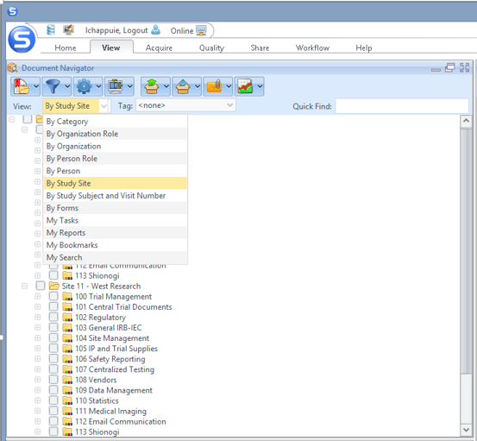

Document Filter
Document filters is a powerful way of adjusting your filing plan to see specific documents, such as Archived documents or documents that are In Review. For instance, you can set preferences to work within only one study, such as Study 100000 shown below. If you don’t see all your studies and documents, check the Filter icon (as shown in the screenshot below) and make sure you have selected the studies that you wish to browse as well as All Documents from the document Filter menu.
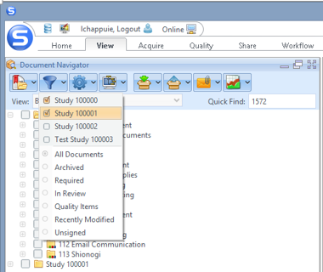

Gadget: Setting Your Personal Viewing Preferences
If you want to further define document visibility settings, like hiding Reserved categories, click on the Settings menu and adjust your document visibility settings to your preferences. This menu provides a convenient way of setting your personal document view settings.
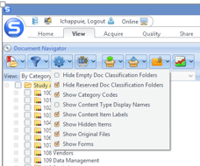

Quick Find: A Way to Find Specific Folders Quickly
Within the Desktop client, you can quickly find folders within your filing plan using the Quick Find. For instance, if you want to find the Curriculum Vitae folder, simply start typing “Curri…” in the Quick Find search box and click enter on your keyboard. The Desktop client will quickly find the first instance of the text “Curri” in your filing plan. Not the right folder? Simply click your enter key again, and the Desktop client will advance to the next folder having “Curri” in the folder name.
Quick Tip: Using the Quick Find will make navigating your filing plan painless. Of course, you can manually navigate the tree if you prefer.
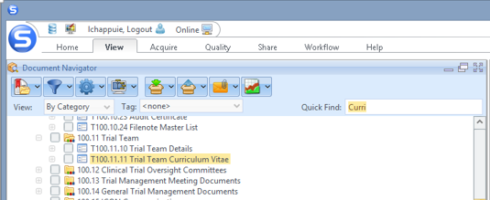

Basic Search
Within the Desktop client, you can conduct a Basic Search which allows you to search for Categories, Content Types, and the content of PDF documents as well as organizations, reports, and help content. Basic Search is located at the upper right corner of the Desktop application. The screenshots below show how you can perform a Basic Search. For the purpose of this search, we are finding all references to Protocol Amendment in SureClinical.
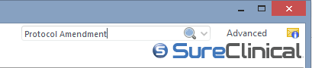
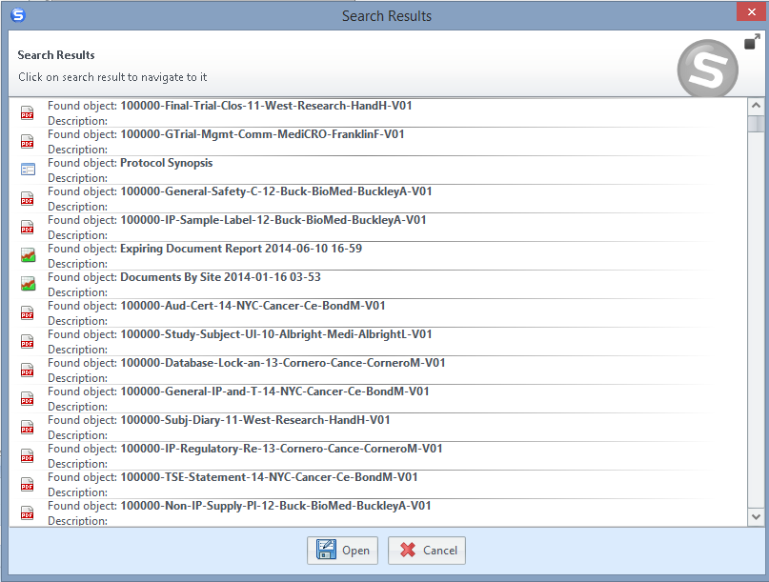

Advance Search
The Advanced Search feature enables you to perform complex search using multiple search criteria (values for metadata properties, audit information, and/or selected documents). To perform an Advanced Search, click on Advanced, highlighted on the image below, and a new window is displayed. This window includes three sections: Search by Document, Search by Metadata, and Search by Audit. In the next several screenshots, you will see how an Advanced Search is performed.
In the displayed window, you can select specific criteria for narrowing your search results. In our example, we select the principal investigator “John Sun” in the person field to find all documents tagged with Dr. Sun in the metadata.
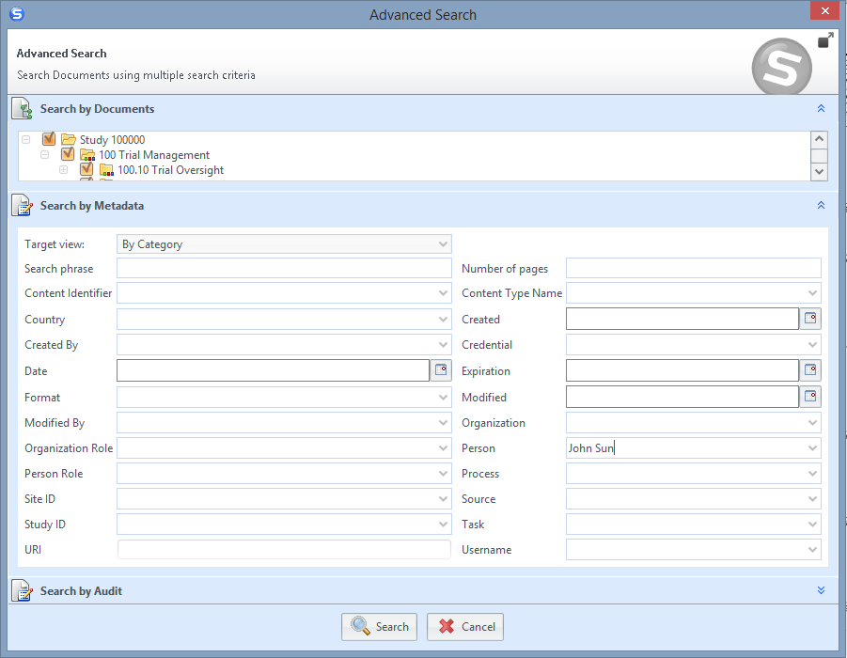
When you click search, the Document Navigator gadget will show the study and all folders that have Dr. Sun tagged in the metadata document properties. You can simply drilldown into the appropriate folders. Note: Documents for Dr. Sun are found in three Content Types: the Principal Investigator Curriculum Vitae, License, and Form FDA 1572.
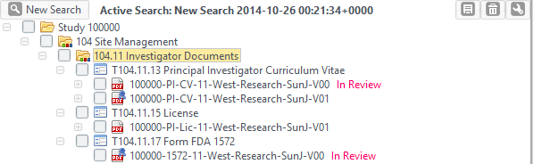

“Right-Clickling” in the Document Tree
For Windows users, you can right-click with your mouse on folders to see the options, as shown in the screenshot below. Typical options include actions such as Move Documents, View Audit Log, Create Workflow Process, etc. The options change according to the context of the document, the status of the document (e.g., In Review), or folder that you are selecting. For Mac users, you can also use right-click menus either through a Mighty Mouse “mouse” to respond to the right click of your mouse button or set your trackpad preferences for tapping on the lower right corner to display these menus.
Quick Tip: In the screenshot below, we are demonstrating the launch of a Create Workflow Process directly from a document in your content tree.
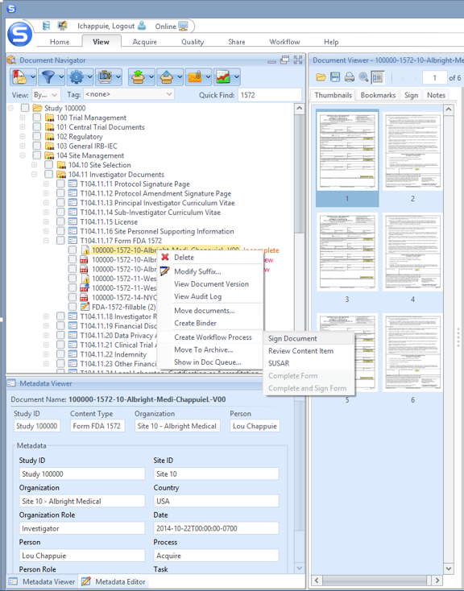

Document Naming Conventions
The Desktop client auto-names your documents when they are imported into your TMF, as shown in the screenshot below. Why is this important? Auto-naming enforces consistency in the document classification names helping to ensure an inspection-ready TMF. The naming convention for a document is as follows: Study Name - Content Type (File Folder) - Site # and Site Name - Person - Document Version Number. Note that, documents that have not been officially moved from the Acquire queue to the archive are not assigned a version number. Instead, they are assigned the value V00 for version number.
Quick Tip: You can easily add suffixes to a document by right-clicking that document in the tree, select Modify Suffix and add a custom suffix to the document.
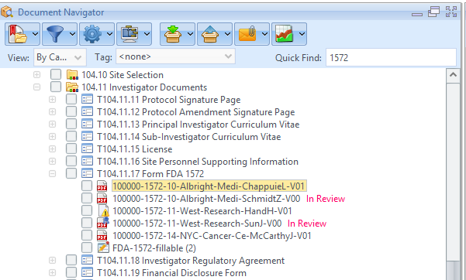

Visual Indicators via Document Icons
The Desktop client provides several visual indicators (via document icons) that reflect the status and the type of the document. There are four types of icons: the PDF Document, Discrepancy, Digitally Signed PDF, and PDF Fillable Form icon. The screenshot below shows the collection of different document icons.
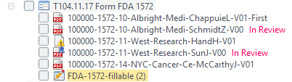
PDF Document: Document has been uploaded and converted to PDF.
Discrepancy: A discrepancy issue has been found in the document that needs to be reconciled.
Digitally Signed PDF: The PDF document has been digitally signed in either the Desktop or the Mobile client.
PDF Fillable Form: The document is a fillable form that can be shared via workflow for completion, upload, and signing. It is important to note that PDF forms do not have site specific metadata associated with them.

Document Status Annotations
The Desktop client further provides several document status indicators that are annotated directly to the right of the document. These indicators provide a further understanding of the current state of the document. The screenshot below demonstrates different document statuses.
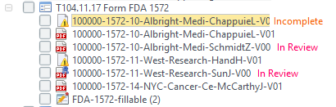
Incomplete: Indicates that a document has been imported; however, a metadata discrepancy has been assigned that needs to be reconciled before moving the document to the archive.
In Review: Indicates that a document has been uploaded but has not been formally quality checked and moved to the TMF archive. All uploaded documents should undergo a review process before residing in the TMF archive.
No Indicator (blank): Indicates that the document is in the TMF archive.

Viewing the Content Model Editor
The Content Model Editor is a powerful tool that allows you to tailor your filing plan to your organization’s needs. For instance, if you want to add new Categories and Sub Categories (e.g., folders) within your study or to modify required metadata (e.g., tags), you will need to switch your view to the Content Model Editor. Simply select the Change View menu and select the option Content Model Editor. While security settings are configurable, this powerful utility is generally only accessible to study administrators.
Quick Tip: After you have completed modifying your tree and metadata, be sure to reset your view to Tree View. Otherwise, you may wonder why you can no longer see the content of study documents in the Document Viewer.
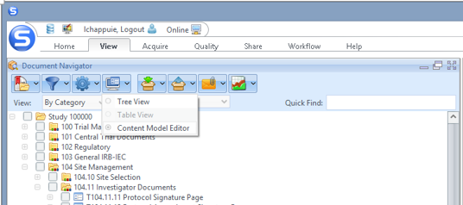

Reserve Folders – “Hiding Unused Folders”
To hide a folder for an OASIS eTMF Category, Sub-Category, or Content Type, you need to Reserve the folder using the Content Model Editor (remember, it’s a right-click of your mouse). The folder will then appear “greyed” out.
Quick Tip: In Reports, you can generate a report (Content Model Editor Report) for auditors that shows the folders that are unused within the study.
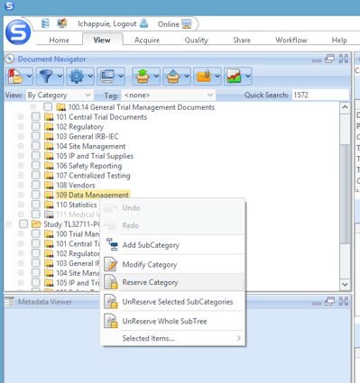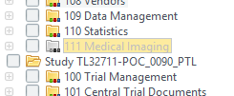

Uploading Documents
There are several convenient ways of uploading documents into your eTMF using the Desktop client. One easy way includes uploading via the Upload Content Item icon which opens the File Upload Wizard. This wizard allows you to search directories on your computer to select documents. In the screenshots below, you will see how easy it is to acquire documents in the Desktop client. In the first step, simply select the Upload Content Item icon.
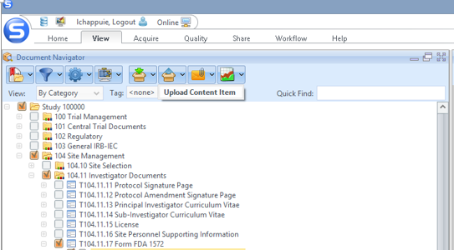
Next select the Folder icon in the File Upload Wizard to open a window to browse your content.
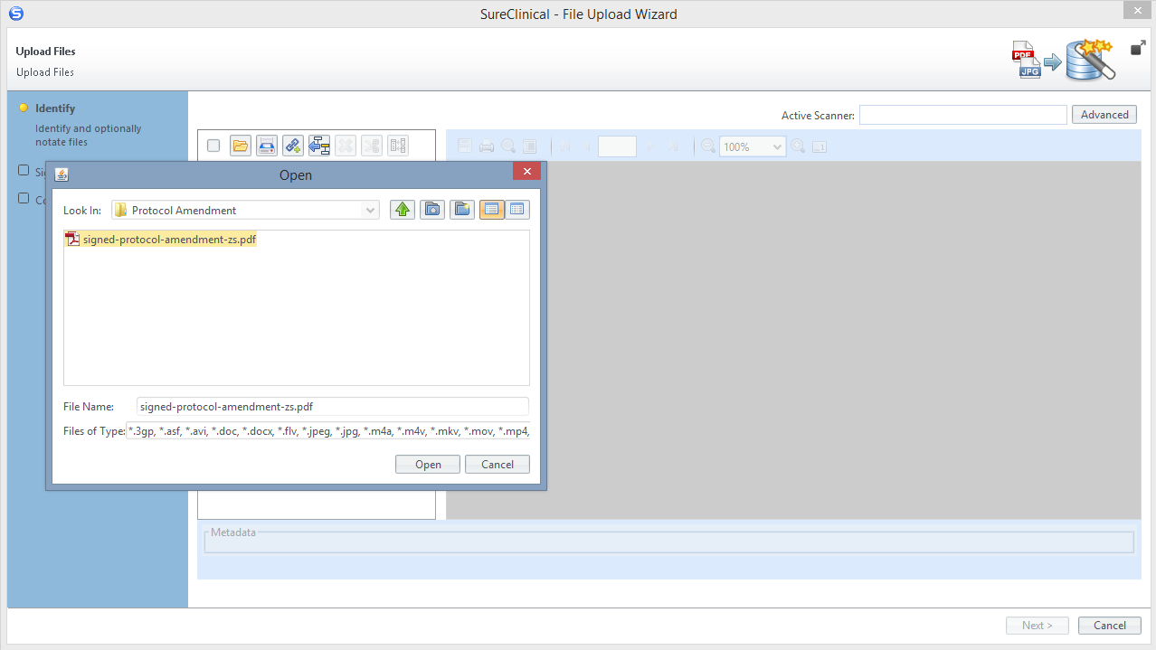
After you have selected your document, simply tag the document appropriately in the metadata area and select Finish to upload the document into your eTMF.

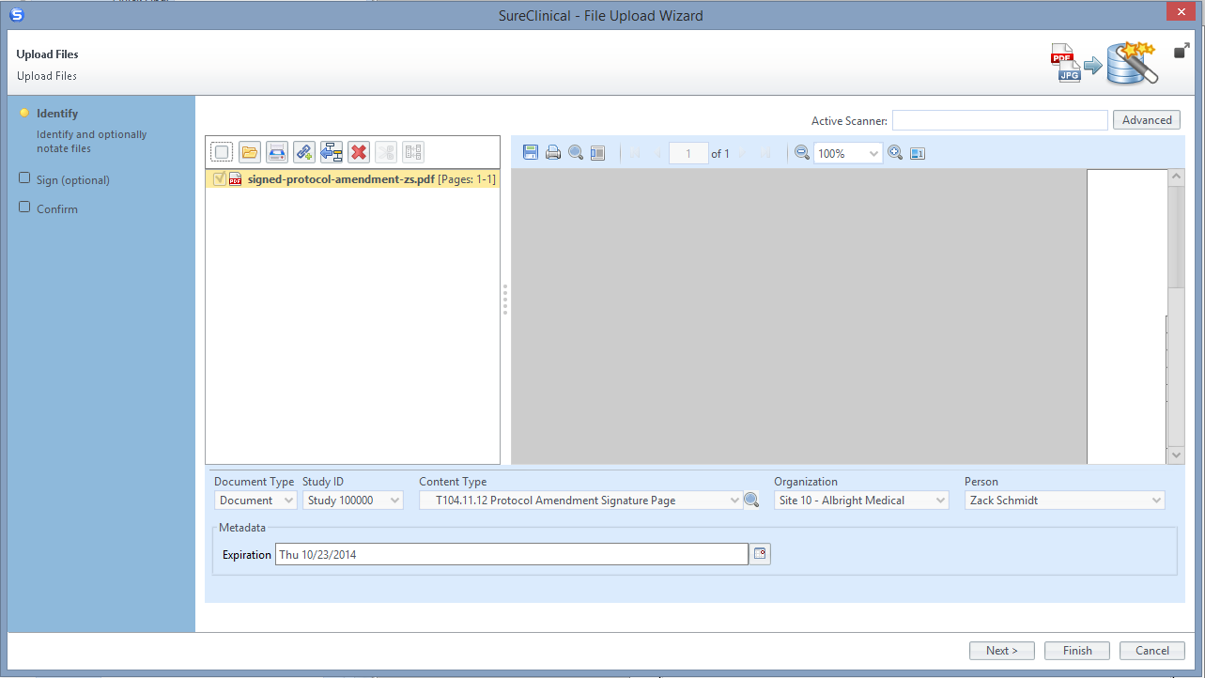

Drag and Drop: The Easy Way to Acquire Documents
The Desktop client provides an even simpler way of acquiring documents in your eTMF. You can simply drag and drop documents from any file folder to any Content Type in your tree. Just open your file folder on your computer, select a document, and drag it directly into the tree. SureDesktop will automatically launch the File Upload Wizard.
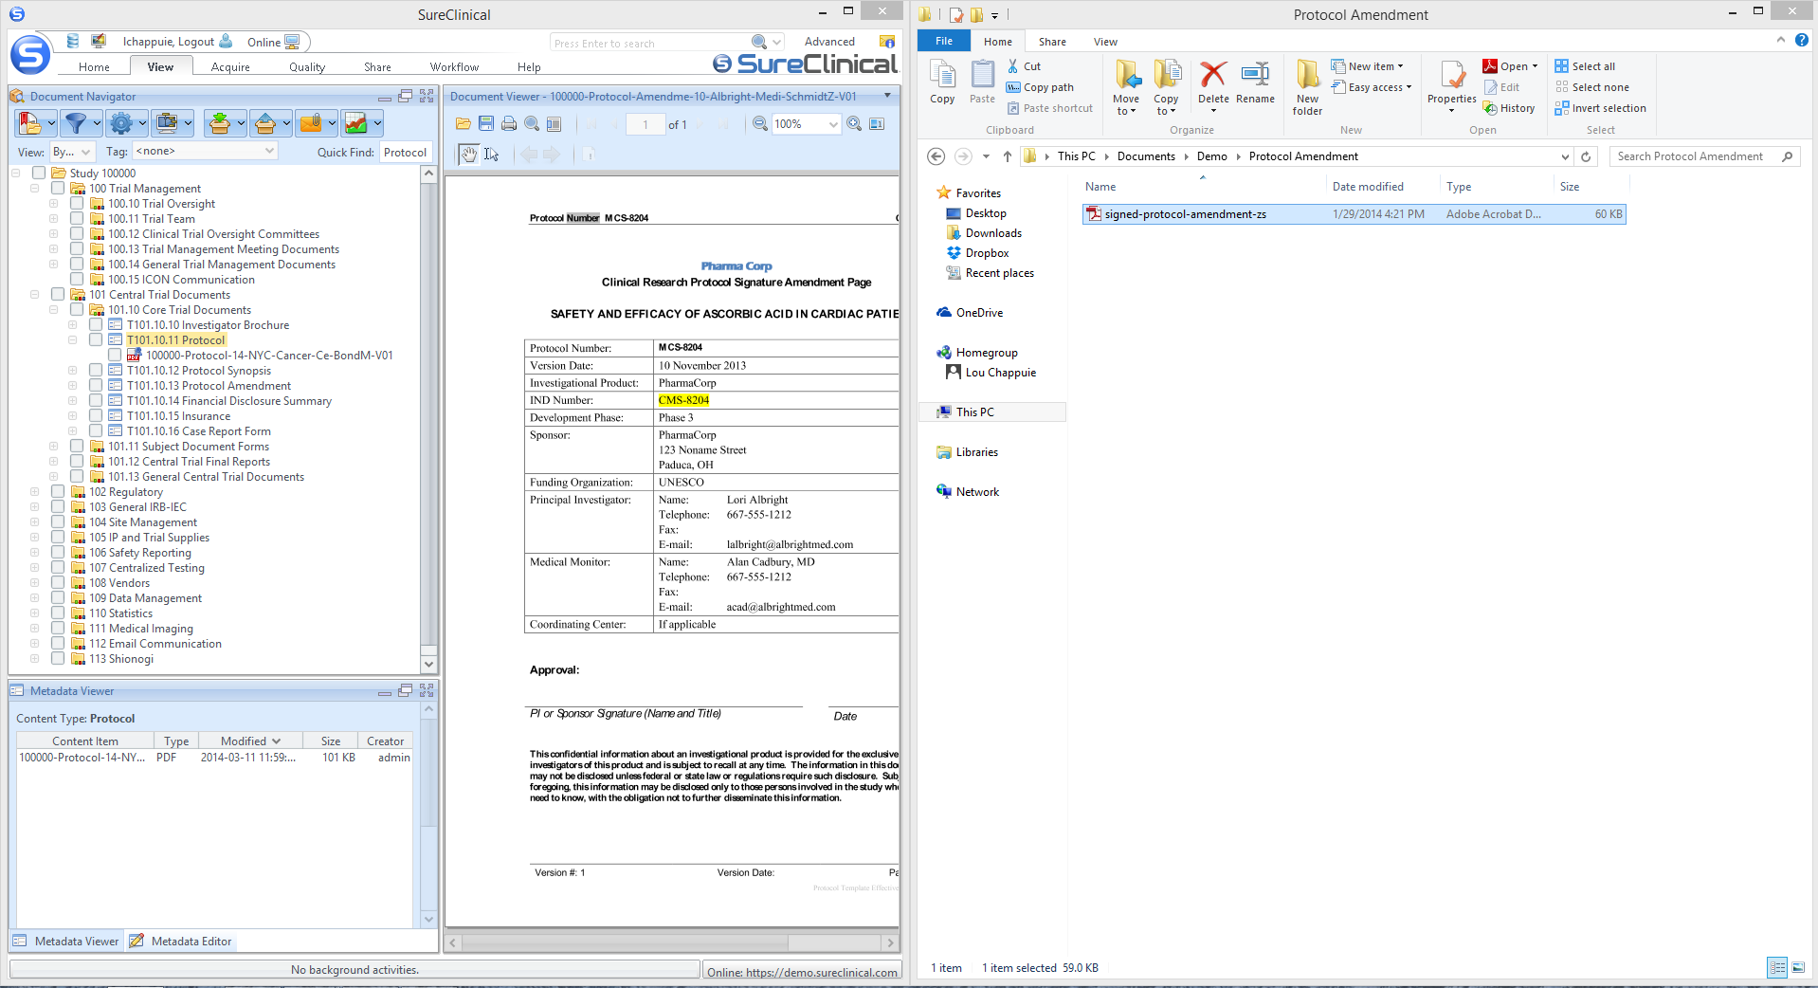

Creating a Binder
Within the SureDesktop, you can quickly assemble a collection of documents as binder to share with individuals within your team. Check the boxes of documents you want to include in the binder. Right-click on any of the selected documents and select Create Binder. When the Create PDF Binder window is displayed, select the Merge icon. Want to be really creative? Once the Binder is saved to the tree, you can share that binder via Bookmarks with a colleague.
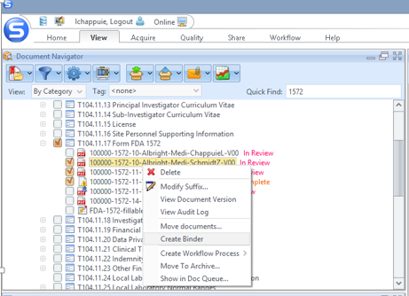
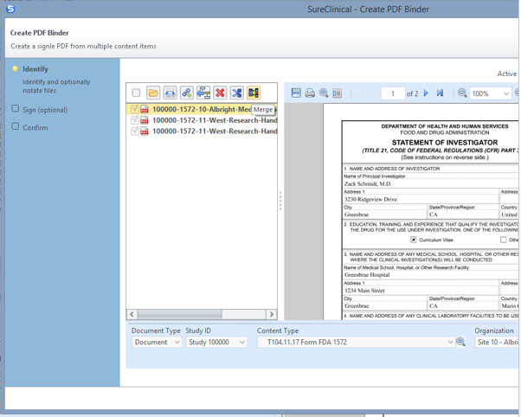

Bookmarks: Securely Share Documents with Colleagues
Bookmarks are convenient ways of sharing information in a secure format with colleagues within your study. The Bookmark Manager is located directly below the SureClinical “S” button. From your document tree, select the document that you are interested in sharing, select the Bookmark Manager icon and then select the Add to Bookmarks option from the drop down menu.
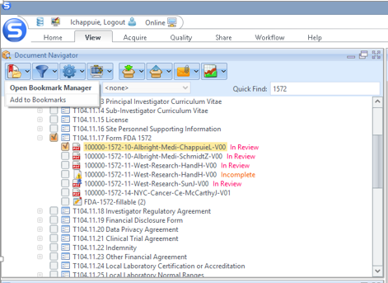
You will then see the Bookmark Content window appears. In this window, select SureClinical users with whom you wish to share the Bookmark. Click Save and the SureDesktop takes care of the rest by sending a secure link to user’s email address. From the email notification, your colleague can access the bookmark online from either SureDesktop or the web client.
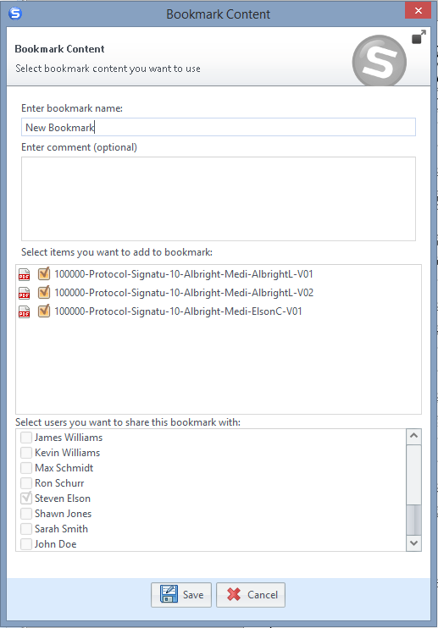

Checkboxes and Clearing the Document Tree
Selecting multiple documents via checkboxes is designed expressly for the sole purpose of taking action on multiple items at the same time. For instance, you may want to download several documents at once.
From time-to-time, you may lose track of the fact that you have checked several documents in different folders in your tree. Then, if you go to upload a document, you notice that the SureDesktop doesn’t know what study or folder to auto classify your document. At first glance, you can find this frustrating. However, the SureDesktop is actually letting you know that you can’t simultaneously upload the same document into multiple folders. In order to clear all checks in the document tree, the easiest method is to select and then deselect the highest folder in your study tree. This clears all checkboxes as shown in the following screenshots. In the first screenshot, you see that there are multiple documents selected within various folders.
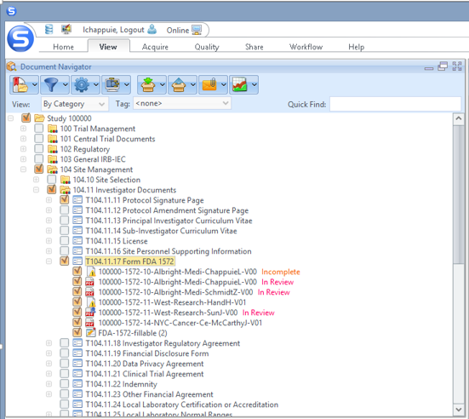
Next, check the highest folder within your study to select all folders as shown in the next screenshot.
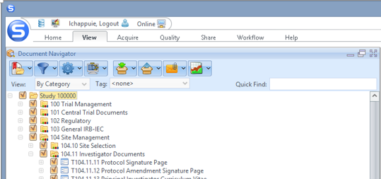
Finally, uncheck the highest folder in the tree and all checkmarks are removed from your study documents as represented in the next screenshot.
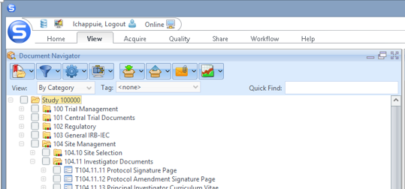

Thumbnails
When previewing a document, you may want to quickly skip to a specific page within the document. Using the Show/Hide Utility Pane in the Document Viewer, you can open the document Thumbnails. This is a convenient way to select and skip directly to a specific page within a regulatory document. In the screenshot below, you can see how to open the Utility Pane and select a specific page.
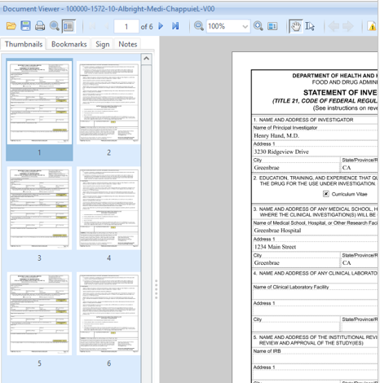

Searching Within a Document
You can also search within a document to find the text that you are interested in previewing. Within the Document Viewer, select the Search magnifying glass. A Search dialogue box will then open that enables you to search text within your document. As shown in the example screenshot below, you can then search for “Name” within the document. Every occurrence of “Name” is then highlighted within your document. You can skip to the right location within the documents by clicking on the Results pane.
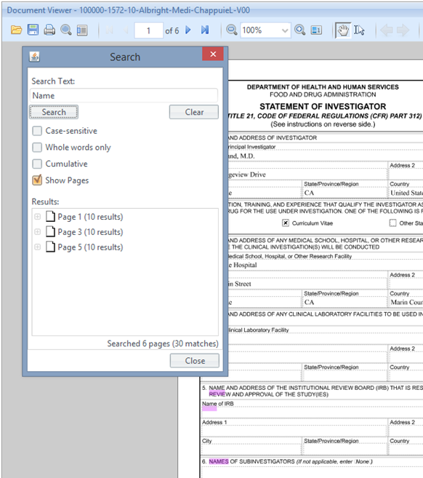

Excel Formatting
When you upload Excel workbooks and sheets, you will want to set your document print boundaries first. By setting your print formatting within Excel, the PDF conversion utility will inherit these formats during the conversion proces, giving your document a professional look within SureDesktop
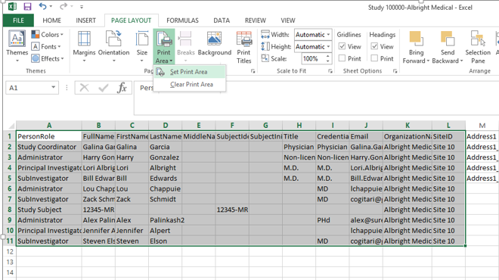

Large Word Documents
From time-to-time, you will find that large Word documents lack some formats when uploaded and converted in SureDesktop. As shown in the screenshot below, you can always save the document to PDF prior to uploading into SureDesktop to verify the formatting and ensure you have the right layout. This can come in handy when the document is large and you’d prefer to see the format before uploading it to the SureClinical Cloud.

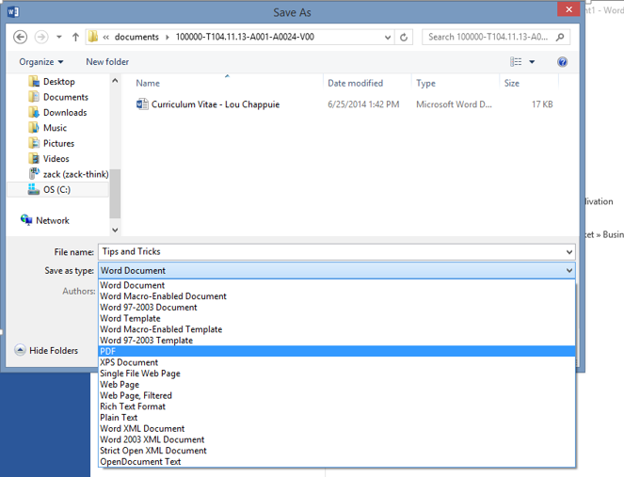

S-Button
The SureDesktop “S-Button” contains many of the powerful tools where you configure your SureClinical options and security settings. The S-Button includes features such as New Archive, Save Archive, User Accounts (security administration), and Application Features (setting role privileges). Simply click the “S” icon in the upper left corner of the application and you can access these features.
Quick Tip: The S-Button contains several advanced features within SureDesktop. It is generally recommended that you limit access to most of these features to only administrators of SureClinical.
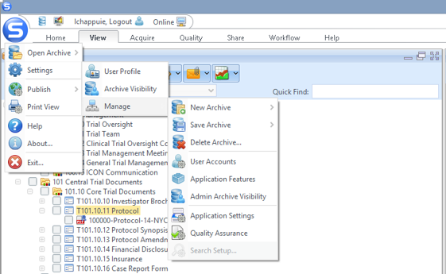

Setting SMS Text Messaging
Not getting SMS text messages for your workflow tasks? You may not have your SureClinical account configured to send you text messages. Every user who has access to the desktop can configure the SureClinical account to send SMS messages to their mobile device. Simply select the S-Button and navigate to Settings User Profile. Once you have opened the User Profile, select the tab Notifications, and check the SMS checkbox for “I want to receive task notifications.”
Quick Tip: If you’re still not receiving workflow task notifications, your Administrator may not have your mobile phone entered on your User account.
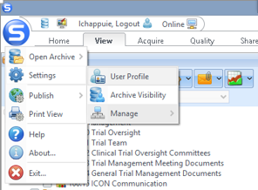
Select the Notifications tab and check SMS for the “I want to receive task notifications via:”
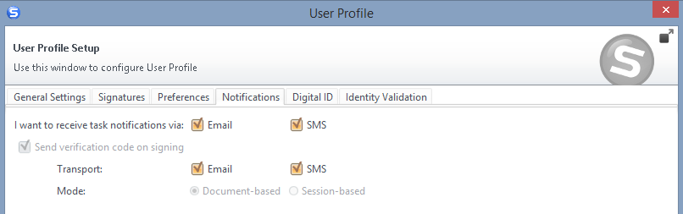

Adding your Company Logo to Reports
Want to add a company logo to your reports? With SureClinical you can easily add your company logo to your reports through Application Settings. Simply select the S-Button and navigate to Settings Manage Application Settings. Once you have opened the Application Settings, select the Reports tab. Select the option “Use custom logo” and select Browse. You can then upload your logo and save the Application Settings.
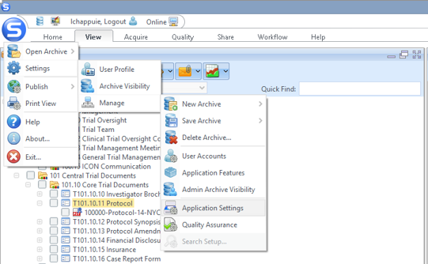
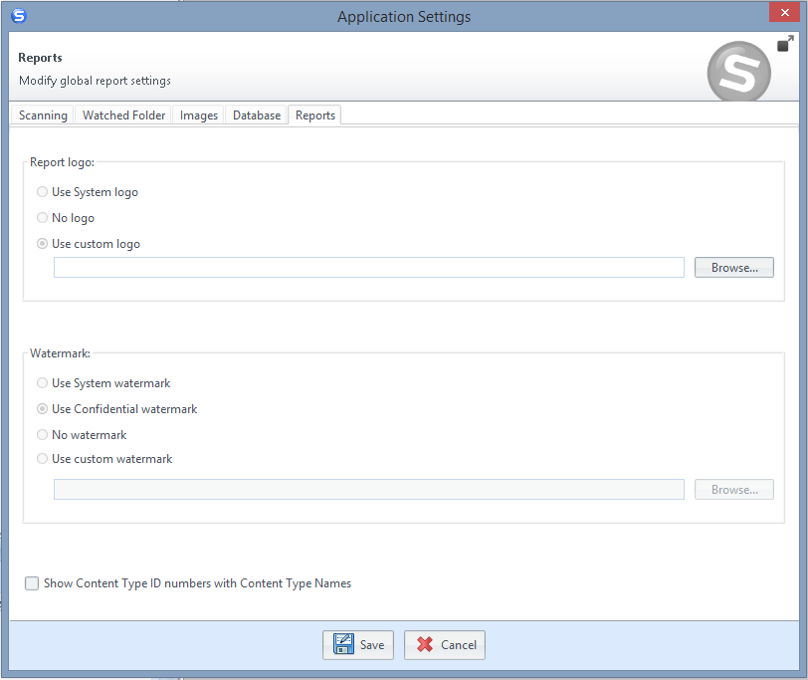

Reports Icon: Creating and Running Reports
Creating reports in SureDesktop is easy. From the View screen, simply select the Reports icon to access both preconfigured reports as well as custom reports.
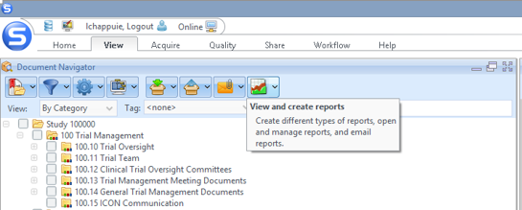
The SureDesktop Report Wizard window will then open. You can then select from preexisting reports or create a custom report via the Custom Report icon.
Quick Tip: Within the SureDesktop Report Wizard, you can save a report as a custom template for reuse purposes (as shown in the next screenshot.)
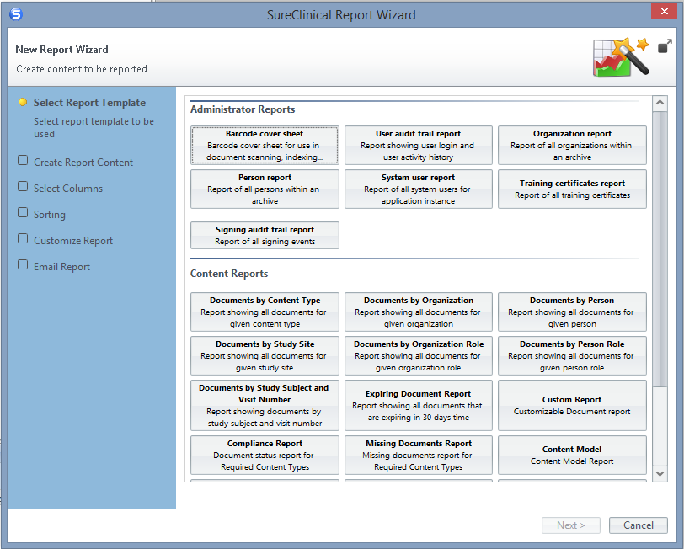
Select “Save report as template” and enter a Template name in the text box. The report will now be available in the Organization Reports.
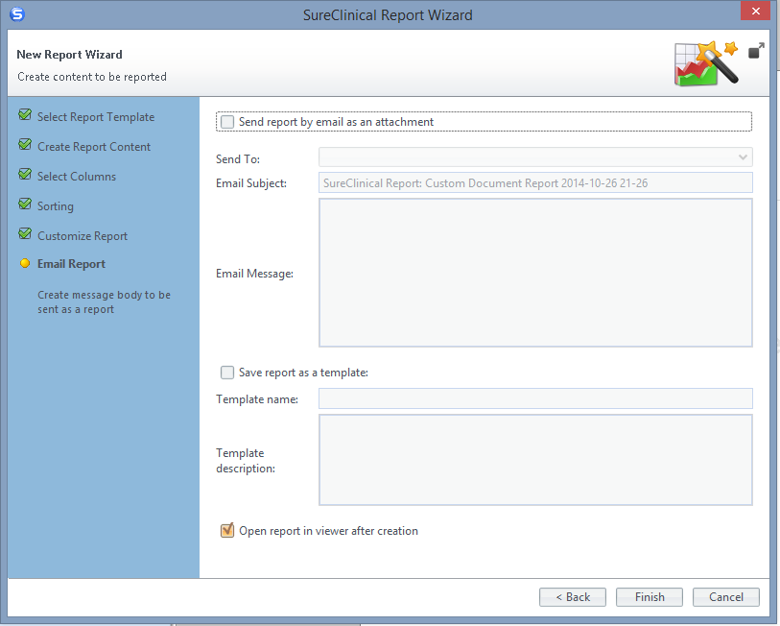f

